Part 1:



Part 2:

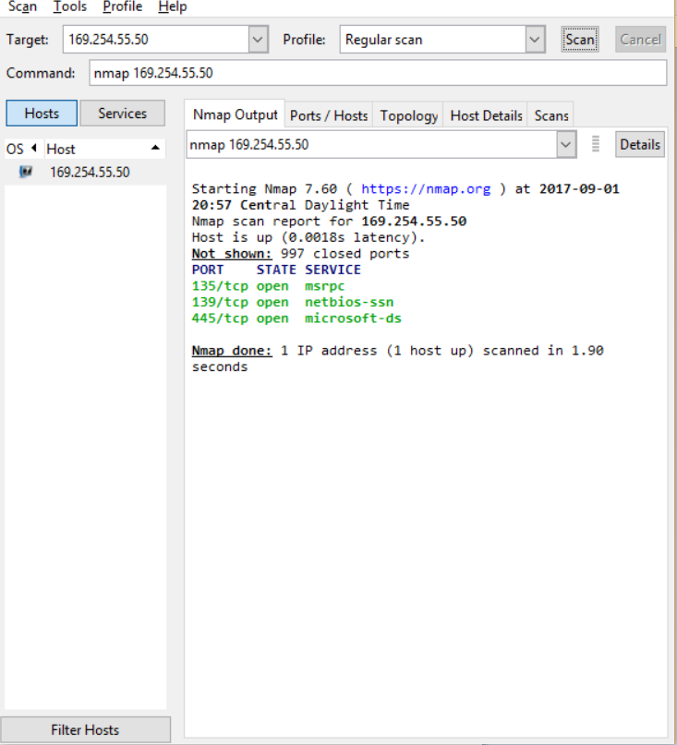

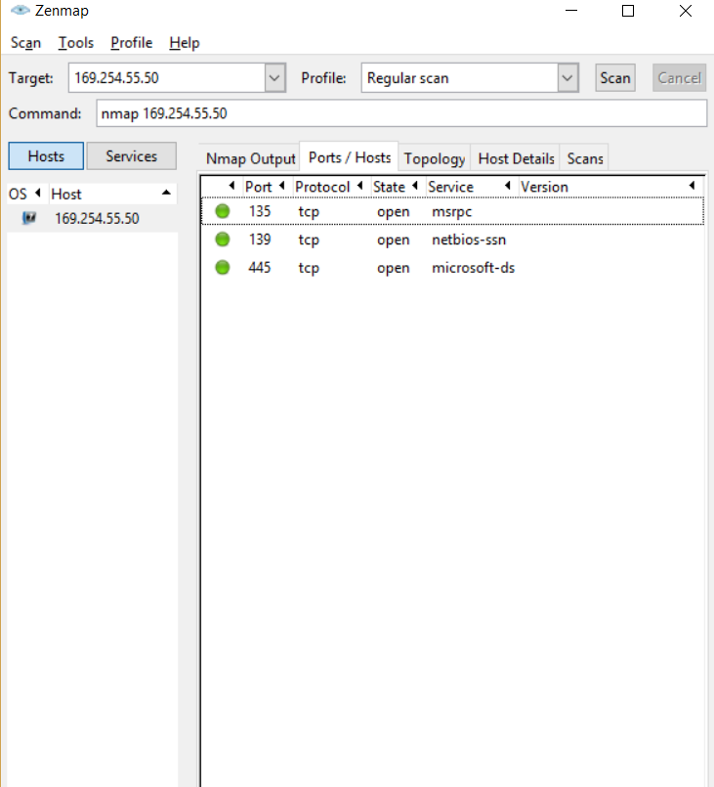

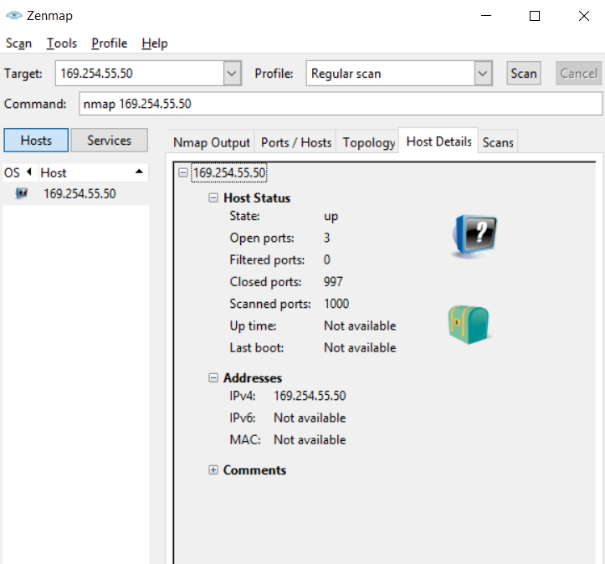

Part 3:

* There are 65535 ports on a computer.
* On this host, there are 3 open ports, running msrpc, netbios-ssn, and microsoft-ds.
* The host’s operating system is Windows 10.
* Hackers can use ports to spread malware by looking for exploitable vulnerabilities. If a port gives the hacker inappropriate permissions, they can use that to plant malware onto the device.
* You can close open ports by closing the program that’s using the port.
* The “no port” option will skip scanning ports and focus of only telling you if the host is active. Also you can scan with “no ping” so that you can see if a host that is blocking the ping probes is active.